

**Tobor Inc.**

Content Aggregation Automation

Detailed Process Description

Version 2

**Revision History**

|  |  |  |  |
| --- | --- | --- | --- |
| **Date Issued** | **Version** | **Description** | **Author** |
| 12/06/2020 | 1.1 | First Draft of the DPD | Daryl Atienza |
| 28/06/2020 | 2.0 | 2nd draft of the DPD | Daryl Atienza |
|  |  |  |  |

**Contributors**

The content of this document has been authored with the combined input of the following group of key individuals.

|  |  |  |
| --- | --- | --- |
| **Name** | **Role** | **Area** |
| Daryl Atienza  Chris Lucas | QA Consultant  Consultant Project Liaison | QAC: RPA Department  QAC |
| David Bradbury | Managing Director | Tobor Inc. |
| Roberto Fernandez | Backend Application Manager and Project PM | Tobor Inc. |

**Business Sign-off**

The following table contains the people required to sign-off and/or review this document and those that require the document for information only.

|  |  |  |
| --- | --- | --- |
| **Name** | **Department** | **Responsibility** |
| Daryl Atienza | QAC: RPA Department | Information / Sign off / Review |
| Christopher Dickinson | QAC: RPA Department | Information / Sign off / Review |
| Jennifer Norris  Roberto Fernandez  Chris Lucas | Testing  Customer Onboarding  QAC | Information / Sign off  Information  Review/ Sign off |

**Document Classification**

|  |  |
| --- | --- |
| **Classification** | Company Confidential |
| **Definition** | Document information is confidential and to be viewed by a selected group of individuals. |
| **Context** | This documentation involves private and sensitive processes that should be securely kept by the company. Inability to keep the information secure will cause significant damage to the credibility of the organisation, leading to several losses (financially and more). |

Contents

1 Introduction **4**

2 Manual Process **4**

2.1 Overview 4

2.2 Detailed Process Flow 5

3 Automation Proposal **7**

3.1 Overview 7

3.2 Automated Process Flow 8

3.3 Target Systems & User Requirements 8

3.4 Impacted Business Areas 10

3.5 Workload 10

3.6 Operational Constraints 11

3.7 Delivery 11

3.8 Contact List 11

4 Automation Details **12**

4.1 Automation Walkthrough 12

4.1.1 User Registration 12

4.1.2 User Update Information 14

4.1.3 User Delete From DataBase 16

4.1.4 Add Items to Queue in Orchestrator: 18

4.1.5 Content Aggregation: 20

4.2 Reporting 23

4.2 Performance Reporting 23

4.2.4 Triggers 24

# 1 Introduction

Tobor Inc has released a content aggregator application (Content-Connect), that collects content from several website resources, and organises the content in a formatted/readable document for the end user to read.  
 The user journey will consist of a registration system, where the user fills out specific fields with their personal details, including a content preference; the data will be sent via user-email to the company. Once received, the user information will be collected and stored within an internal database, and a receipt email will be sent to the user, to inform them of their successful request.   
 The user’s request for content is queued and executed at a certain time-interval, and once all the appropriate data is collected and formatted, it is emailed back to the user, in the form of a text-document. Users should be able to make a request for a change in their information, or to be removed from the overall service.   
 Automation will be used for the user-data gathering/collecting and storage of information, as well as when the data is being collected from the websites and aggregated to a single document. This DPD will outline the manual processes involved, as well as the methodologies/mind-set when going about the automation.

# 2 Manual Process

## 2.1 Overview

Overview of the manual process as it stands currently. Includes bullet pointed list of high-level steps to take to run the process.:

The initial process is triggered, when the Company (Tobor Inc.) receives an registration email from the user’s email, providing a fully filled out application form and the desired content categories. The automation robot will collect the data, store it and process the request in a queue where it will wait until the intended interval.

* Step 1: Tobor Inc. receives an email from the user:  
  - 1.a: Tobor Inc will sort the email based on the subject, whether it be; Registration; Update; Unsubscribe.   
  - 1.b: (IF) subject is “Registration”: The individual will read the email, which contains a table of the User’s details (first name, last name, address, phone number, email, content preference, interval preference), and manually inject the information in the appropriate fields within the User database. Once the company has received the user information, an email receipt (stating that the user’s details have been received and handled promptly) will be sent back to the User - to the user’s email which contains the registration table.   
  - 1.c: (IF) subject is “Update”: The email will contain a table of information, similar layout to that of the registration email, however it contains user details that are already located within the User database. The table will contain a few updates/alterations to the User’s details, with the exception of their Email (this stays static - due to project parameters). The Individual will read the table, and proceed to locate the existing user within the Database, once located, the User’s details will be updated where appropriate (i.e “Last Name” or “Content Preference”). The company will send an email receipt to tell the user once their details have been changed.   
  - 1.d: (IF) subject is “Unsubscribe”: The Email will contain a similar template to that of both registration and update. Using the provided email within the table of contents, the individual will find the corresponding email in the user database, and delete that row from the database where appropriate. The Company will send a receipt, through email, stating that the user has been removed from the database.
* Step 2: Based on the User’s content preferences, located within the database, information will be aggregated and organised into a single email, which is to be sent off at a scheduled time, outlined by the User, in their details.  
  - 2.a: Before sending the email, the content will be checked to see if there is any repeated information, and ensure that information is in a readable format.
* Step 3: Once content is deemed presentable and appropriate, it is sent off to the appropriate user.
* Step 4: At the end of each working day, a report is compiled, which contains the process that took place during that working-day. The report may contain content information, user status’ and general activity with the application.
* Step 5: The report is compiled within a document (word/pdf) and sent off to Roberto Fernandez. .

Acronyms – detail the meanings of any acronyms used above e.g. systems, clients etc.

## 2.2 Detailed Process Flow

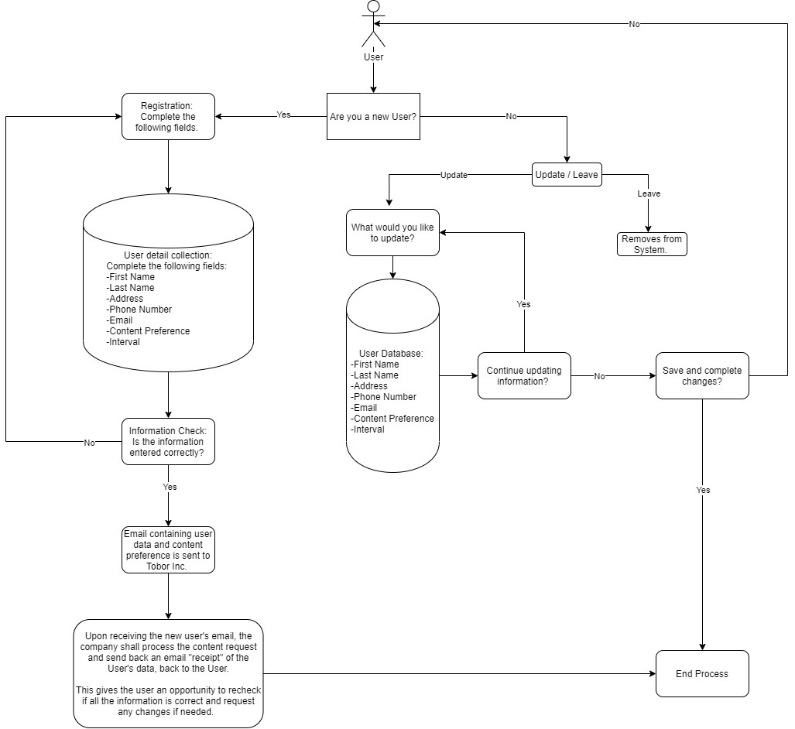

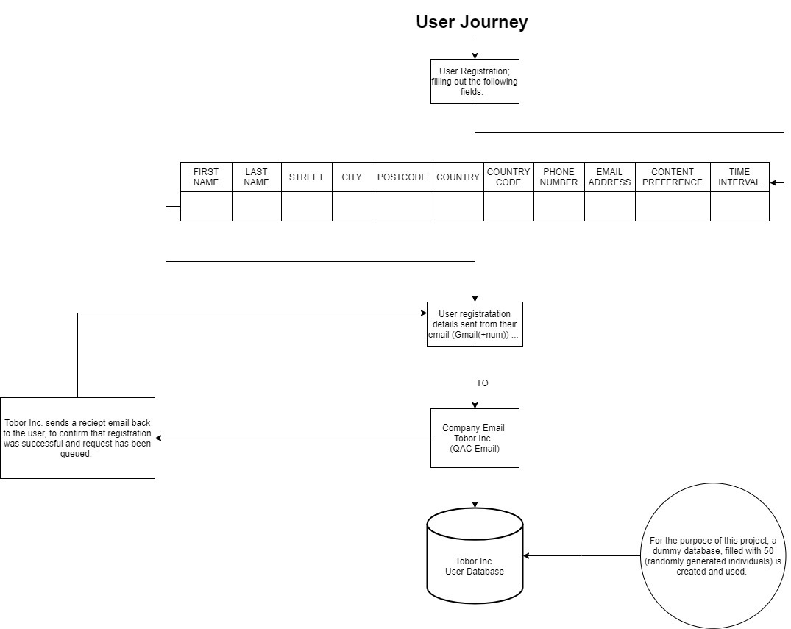

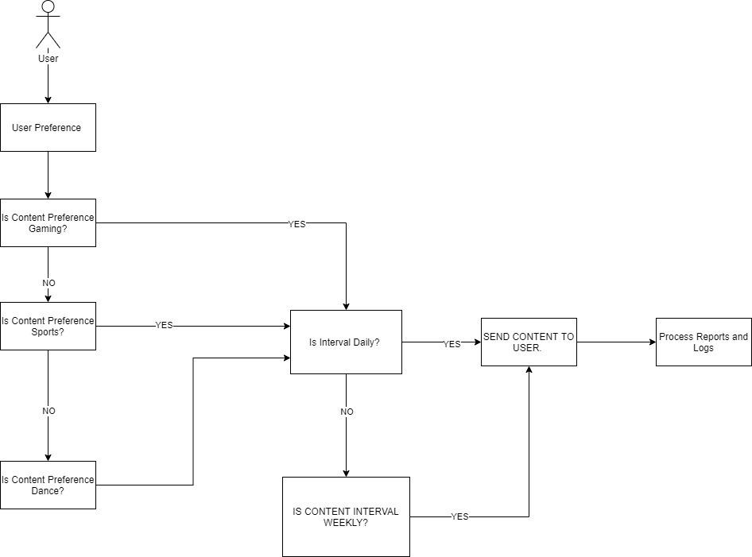

# 3 Automation Proposal

## 3.1 Overview

The Flow-diagrams detail the manual process flow of the end-to-end processes. QA Ltd has proposed to integrate automation for the following processes.

Automation Process 1 - Registration of User:  
- Read the Tobor Inc. inbox.   
- Scan for emails, specific for “Registration”.   
- Open/read any “Registration” emails.   
- Scrape the details from the table of contents.   
- Format the information into a datatable format, so that it can be injected into the current User Database.   
- Send a confirmation receipt to the user, which states a successful registration process.   
- Log the user registration and collect the report into the “reports document” ready to be sent off at the end of the day.

Automation Process 2 - Unsubscription of User:   
- Read the Tobor Inc. inbox.   
- Scan for emails, specific for “Unsubscribe”.   
- Open/read any “Unsubscribe” emails.   
- Scrape the details from the table of contents.   
- Compare the details to an existing user within the User database.  
- Once the corresponding user has been found, delete their details row, from the User database.   
- Send a confirmation receipt to the user, which states a successful Unsubscription process.   
- Log the user unsubscription and collect the report into the “reports document” ready to be sent off at the end of the day.

Automation Process 3: Update User Information:  
- Read the Tobor Inc. inbox.   
- Scan for emails, specific for “Update”.   
- Open/read any “Update” emails.   
- Scrape the details from the table of contents.   
- Compare the details to an existing user within the User database.  
- Once the corresponding user has been found, change any fields appropriate to the outlined details within the email.   
- Send a confirmation receipt to the user, which states a successful Update process.   
- Log the user detail updates and collect the report into the “reports document” ready to be sent off at the end of the day.

Automation Process 4: Content Aggregation:  
- Read the content preference field of the User database.   
- Depending on the specific content preference, outlined by the User, the topic will be used as a reference of aggregation.   
- The Automation will collect information from predefined websites and sources.   
- The content will be collected and formatted into a readable text format.   
- This is placed in an email, which is to be sent off to the User, at either a daily or weekly interval.   
- The interval is outlined by the user and preferences are stored in the database, but the orchestrator will decide the timings.

Automation Process 5: Reports handling:  
- Daily activity within the application, and its processes will be logged.   
- The logged activity will be collected and formatted in a single document.   
- The report document will be formatted into a word doc/pdf and to be sent off to Roberto Fernandez.

## 3.2 Automated Process Flow

The automated process replicates the manual process, replacing the “manual” aspect by carrying out each individual process using a backend application manager, which automates through the whole sequence, once triggered/scheduled.

## 3.3 Target Systems & User Requirements

|  |  |  |
| --- | --- | --- |
| Name | Description | User Permissions/Access |
| MS Outlook | Email inbox. | Simulates Tobor Inc.’s inbox, and receives the User’s emails. Provides access to the information in those emails, and is used for the automation processes. |
| GMail | Email Inbox, which simulates the user’s email. This is an inbox that was created by QA to send the registration/unsubscribe/update emails to the outlook email inbox (Tobor inc.) |  |
| MS Excel | Used to simulate the internal database of Tobor Inc, which holds 50 base (randomly generated) users. |  |

## 3.4 Impacted Business Areas

Areas could involve:

* Backend Application Managers.
* Content collectors.

## 3.5 Workload

Metrics related to the automation:

|  |  |
| --- | --- |
| Are there any periods when a higher workload is anticipated? | Tobor Inc has stated that spikes occurred during periods of major news stories or sporting events, so it is to be expected for future references. |
| How many people do this process per day? | 1 |

**According to the information by Reoberto Fernandez:  
- An average of 15 minutes is dedicated to scheduling a registration, updating the user and deleting any users. This process is conducted by a single user.   
- Content aggregation however may take up to 3 hours.  
- Email send-off will usually take an hour.   
- Tobor Inc. currently holds a user database of 567 users.   
  
DP - Duration of Process  
R - Registration   
U - Update  
D - Delete  
CA - Content Aggregation   
ES - Email SendOff**

* User Registration/Update/Delete = 15 minutes (DP) x (35R + 15U/D) = 15 x 50 = 750 minutes (12.5 hours) daily
* CA + ES = 3 hours + 1 hour = 4 hours Daily Average
* Producing Reports = 1 hour
* Total process hours = 12.5 + 4 + 1 = 17.5 hours.

In Total, the manual process consumes about 17.5 hours, on a day-to-day basis. Therefore the automation would be saving the company 17.5 hours of work effort daily, which is about 87.5 hours weekly and overall 350 hours monthly.

**Automating the steps below will realise an average time saving of 1050 minutes (17.5 hrs) per day for Content Aggregation:**

## 3.6 Operational Constraints

* Operation holds little constraints, as the automation is run by an unintended robot. With the way the automation is set, the system should run more or less 24/7. With the exception of 11:30pm - 00:00am, as it spends the whole day collecting user data (registrations/updates/deletes) and aggregating content, according to the category that the user’s have specified. The cut off point should be around 11:30, which is when the automation will have triggered it’s queues, to either send the content daily, or weekly, depending on the user’s interval preference.

## 3.7 Delivery

The Delivery of this project was originally stated to be 26th of June 2020, however due to certain circumstances, the delivery deadline is now 29th of June 2020.

## 3.8 Contact List

List of key contacts for the project:

* David Bradbury – Managing Director
* Roberto Fernandez – Backend Application Manager
* Chris Lucas – Project Manager
* Daryl Atienza - RPA Consultant
* Christopher Dickinson - RPA Consultant
* Jennifer Norris - RPA Consultant
* Angel Alcala - RPA Consultant

# 4 Automation Details

## 4.1 Automation Walkthrough

### 4.1.1 User Registration

* Beginning of User_Registration Sequence: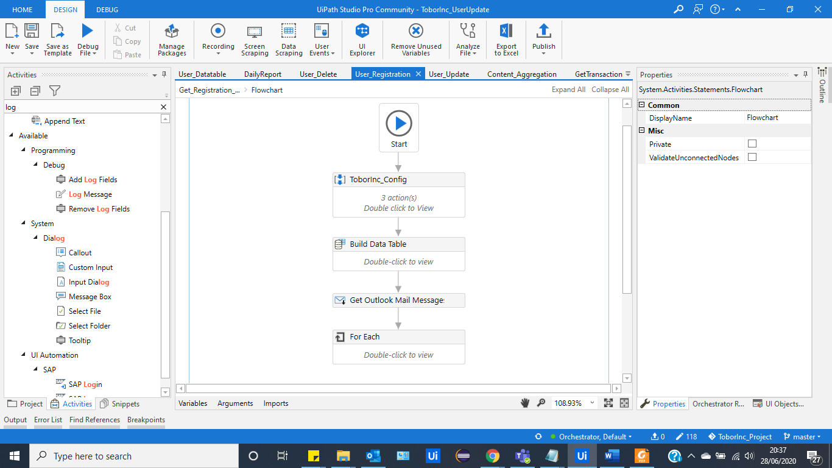
* Build-Datatable mimics the fields, within the UserDatabase and allows any data, read from the emails to be places in a datatable format, once the email’s body has been converted to an array(separate lists of information that fit within the appropriate fields).   
  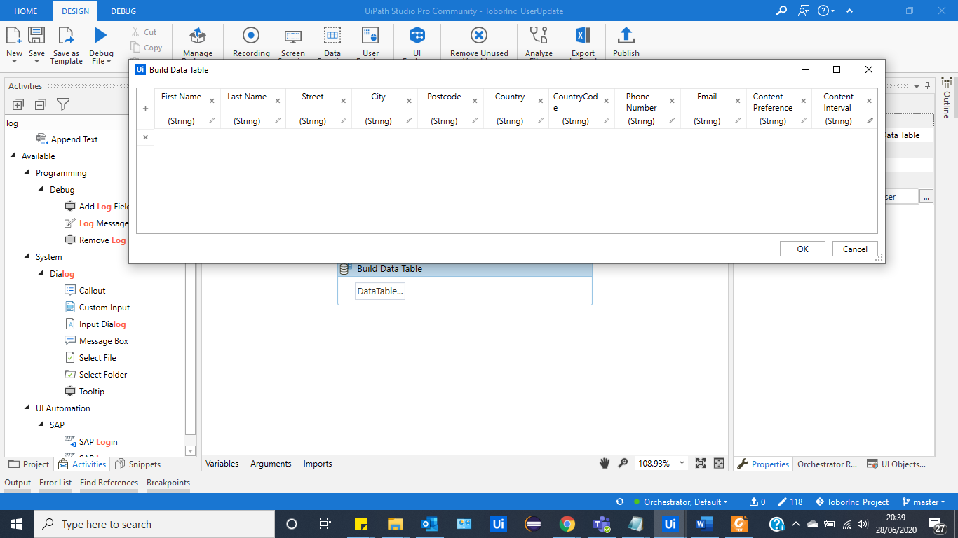
* After it will access the intended email account (inbox), which in this case is the QAAccount, and it will read the desired inbox, and search for any emails that contain a subject that refers to “Registration”.   
  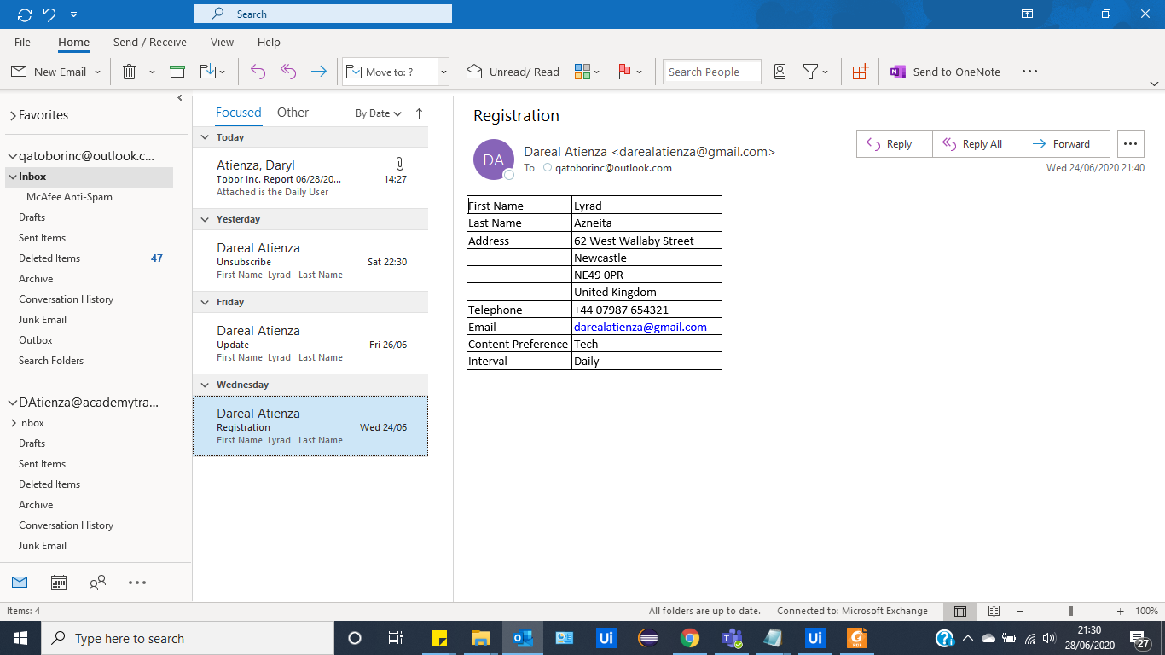  
  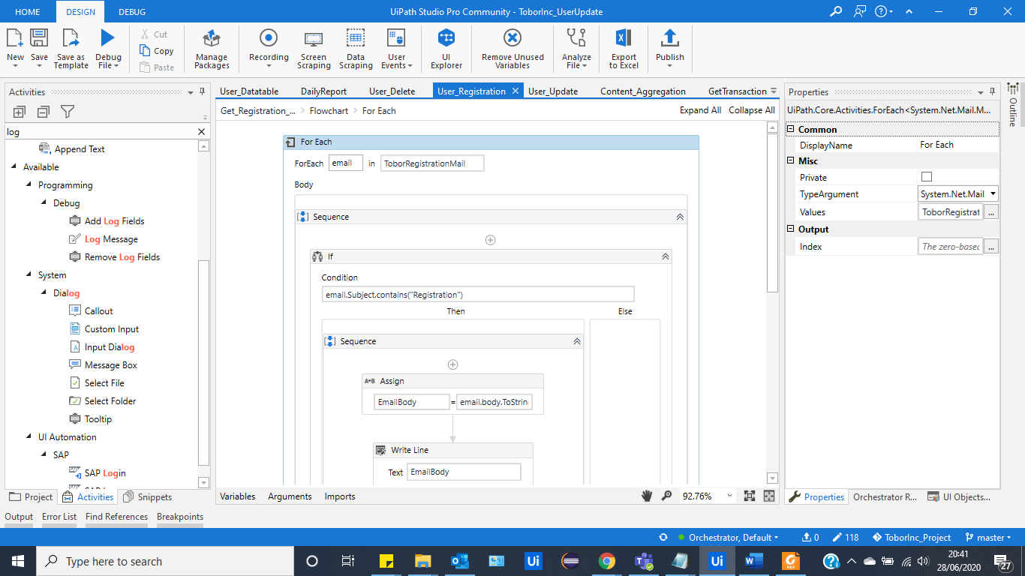
* The Automation will scrape the data within the body of the registration email, which is in a format of a table. Using string manipulation, the automation will separate the table’s information and output it into the “build-datatable”, as a new row of data. This is then added onto the actual database as a new user. Once completely added, the Automation will send a receipt email back to the new user, informing them of the successful activity.   
  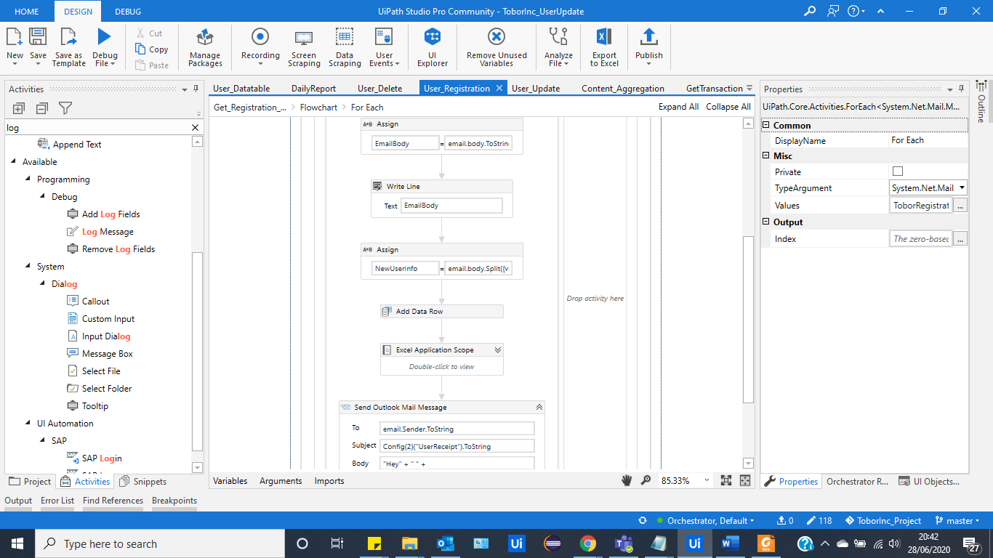

### 4.1.2 User Update Information

* The robot will access the intended email account (inbox), which in this case is the QAAccount, and it will read the desired inbox, and search for any emails that contain a subject that refers to “Update”.   
  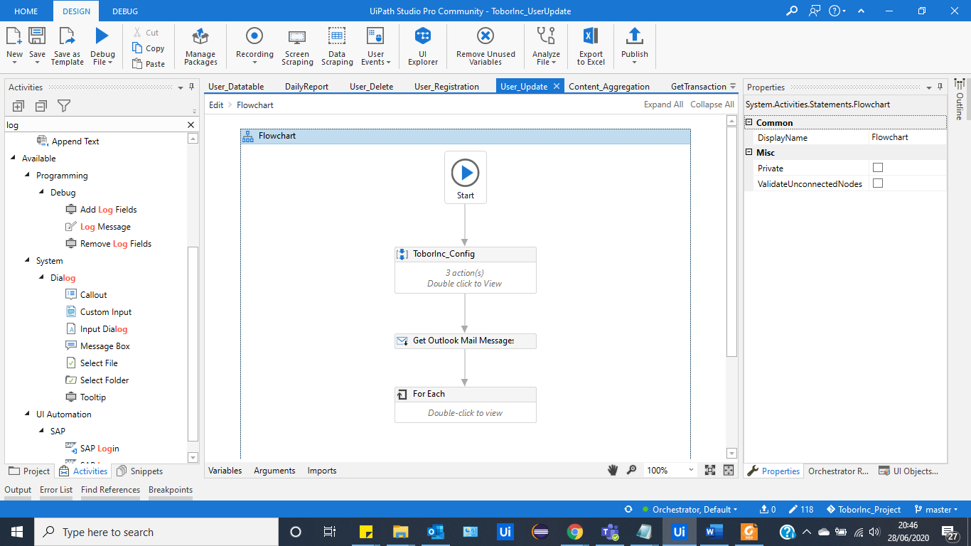
* Similar to that of the Registration automation, it will read the desired mail, scrape the data and format the data into the desired information for the appropriate fields within the database.  
  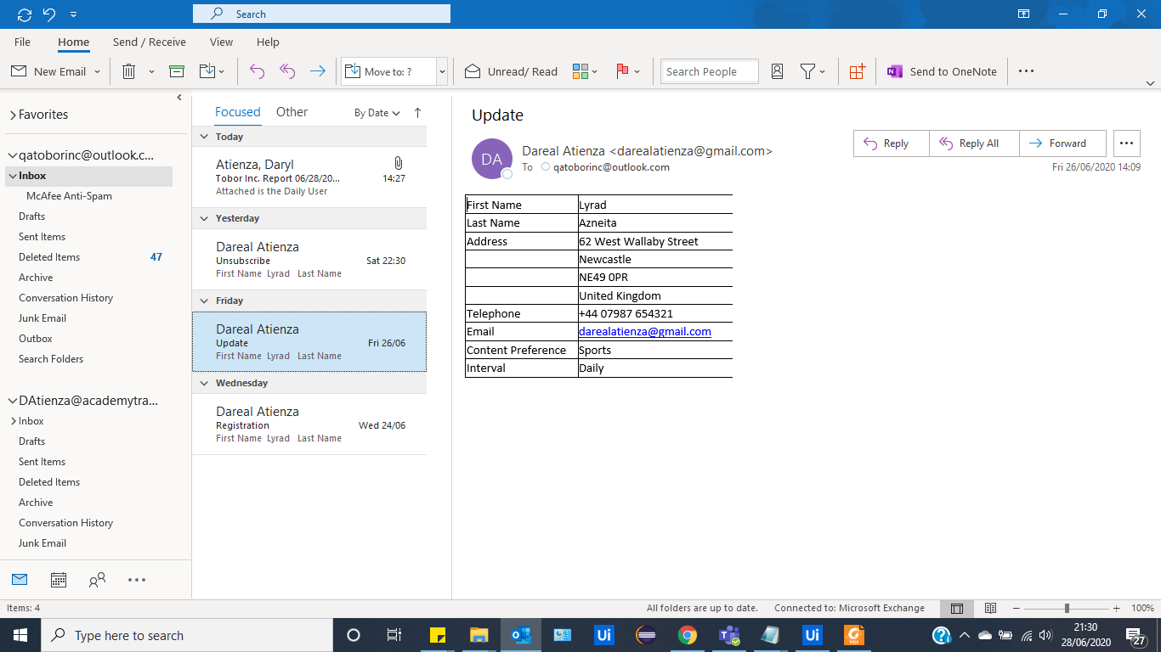
* Due to the nature of this project, the email of the individual is treated as static, and unchangeable, this means that the robot will use this as a unique key, to access a specific user within the database.   
  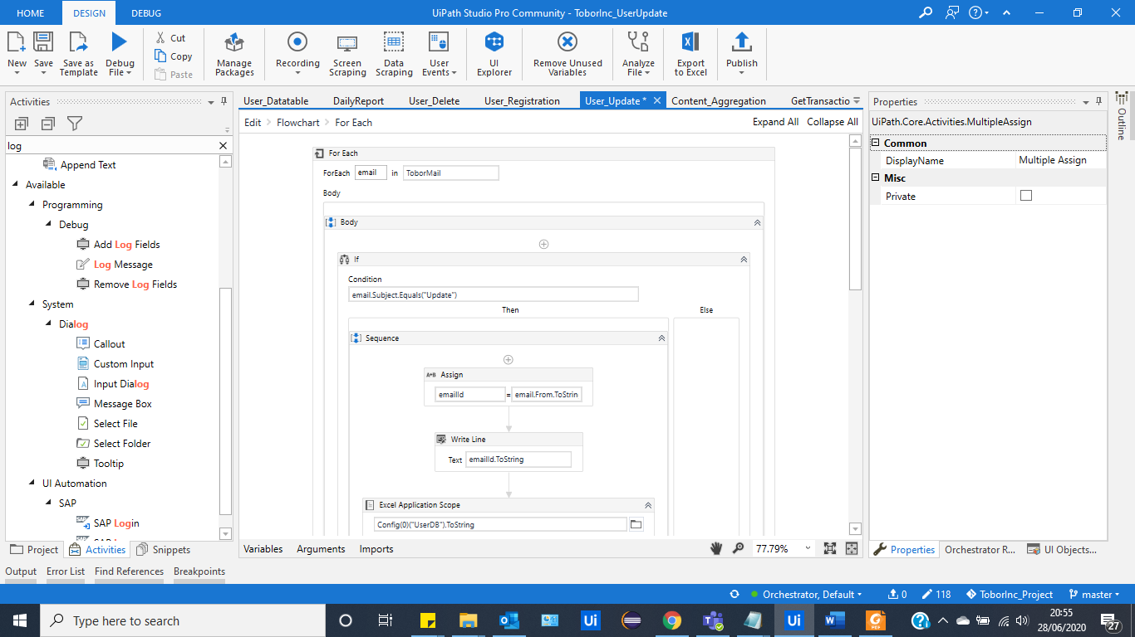
* The robot will grab the email address from the update-email, and compare that email to any existing email within the current database. Once found, the robot will proceed to re-write that whole row, according to the updated information located in the table within the Update-Email.   
    
  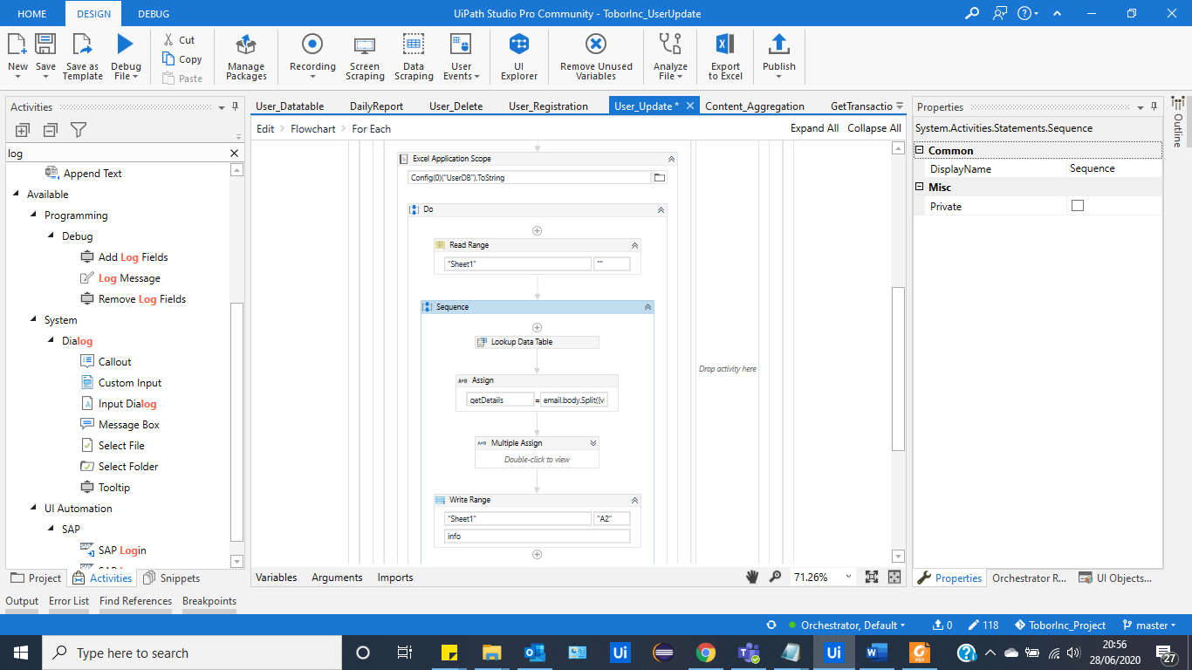
* Once The Update is complete, the robot will proceed to send a receipt back to the user, informing them that their changes have gone through and are being applied.

### 4.1.3 User Delete From DataBase

* The robot will access the intended email account (inbox), which in this case is the QAAccount, and it will read the desired inbox, and search for any emails that contain a subject that refers to “Unsubscribe”.   
  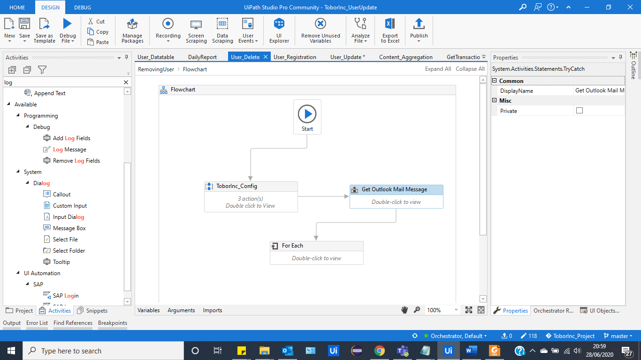  
  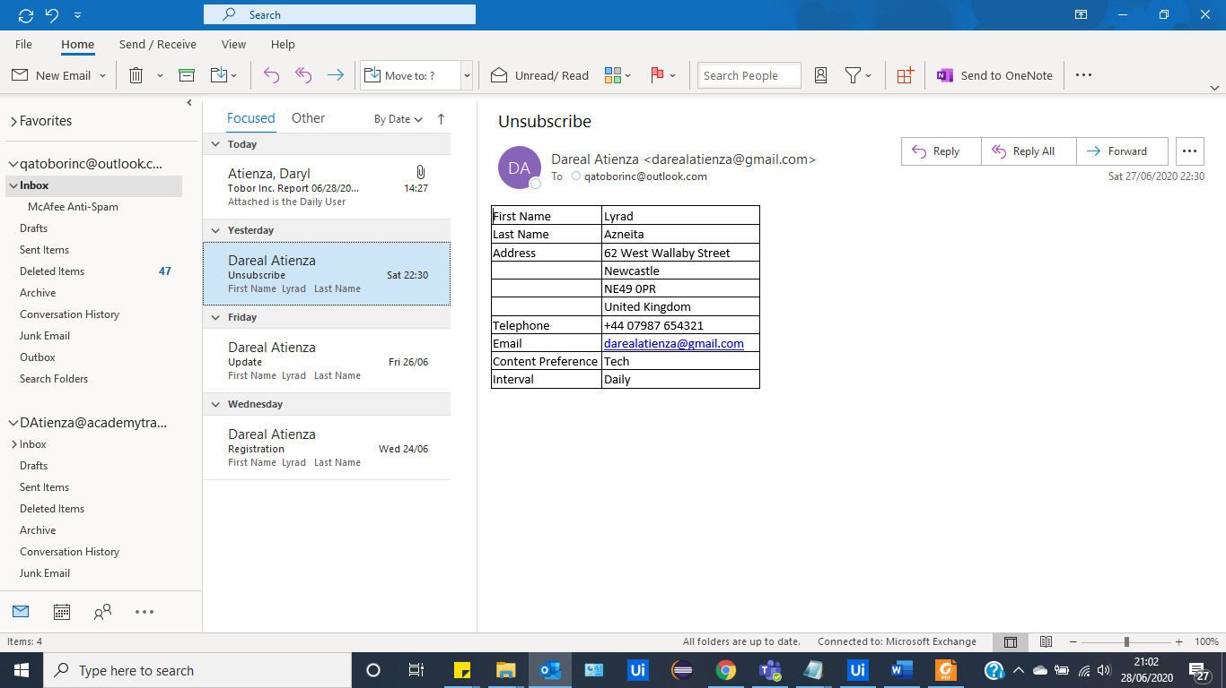
* Similar to that of the Registration automation, it will read the desired mail, however, it will scrape the email from the user, and search the current database for a matching email. Once a matching email has been found, the robot will proceed to delete the whole row of information.   
  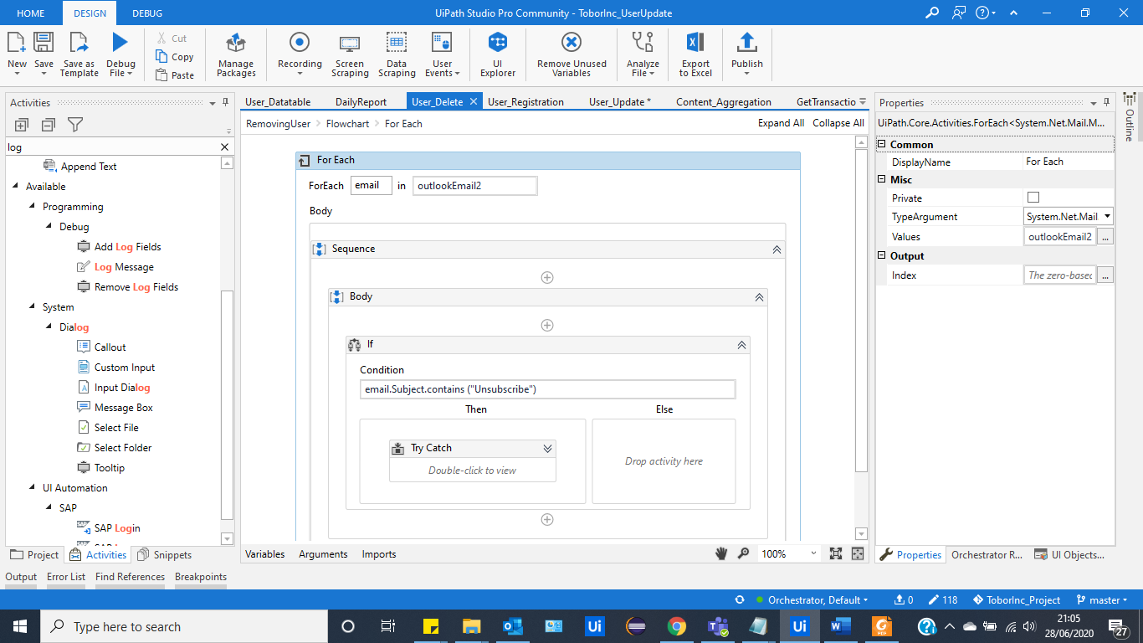
* An Email Receipt is sent to the user, once their information has been deleted.   
  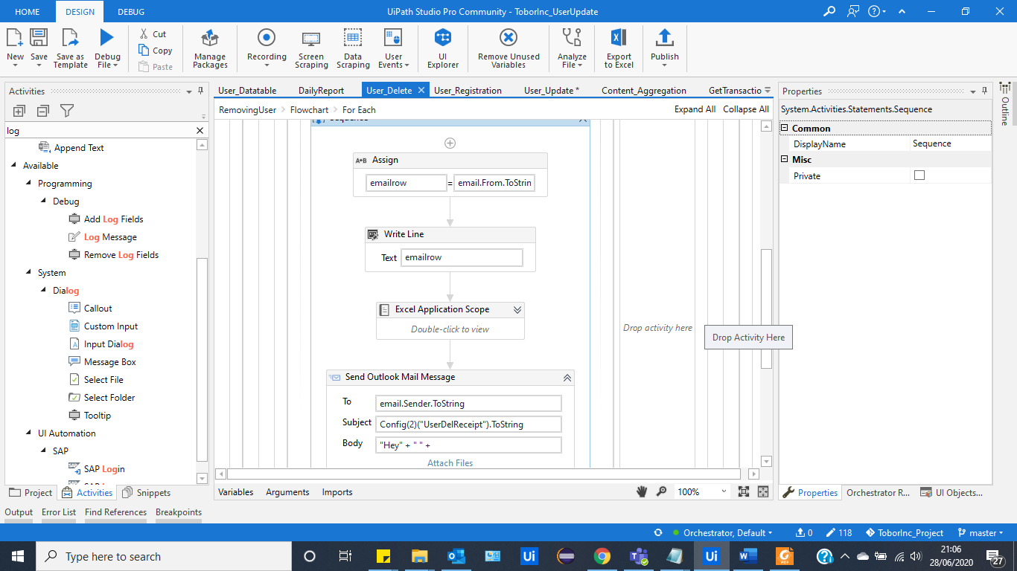

### 4.1.4 Add Items to Queue in Orchestrator:

* The robot will access the database, and read the whole sheet, which contains all the user information.   
  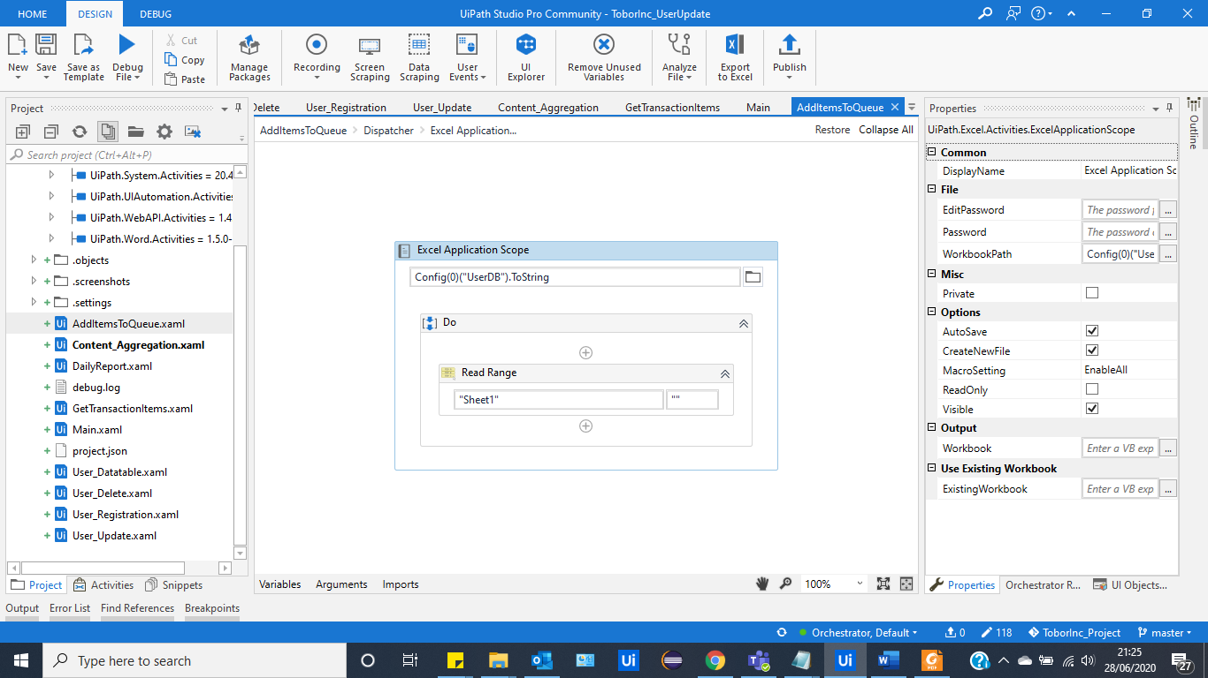
* Once accessed, the robot will then collect the data, and “bulk” push the data onto the designated queue, within the orchestrator.  
   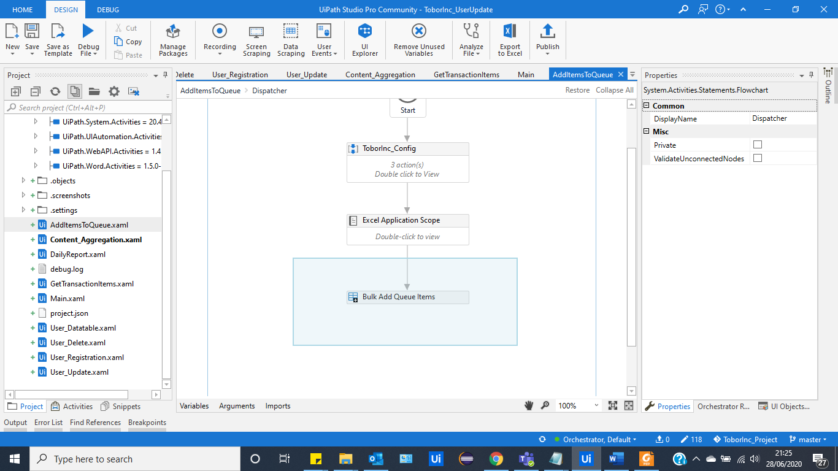  
  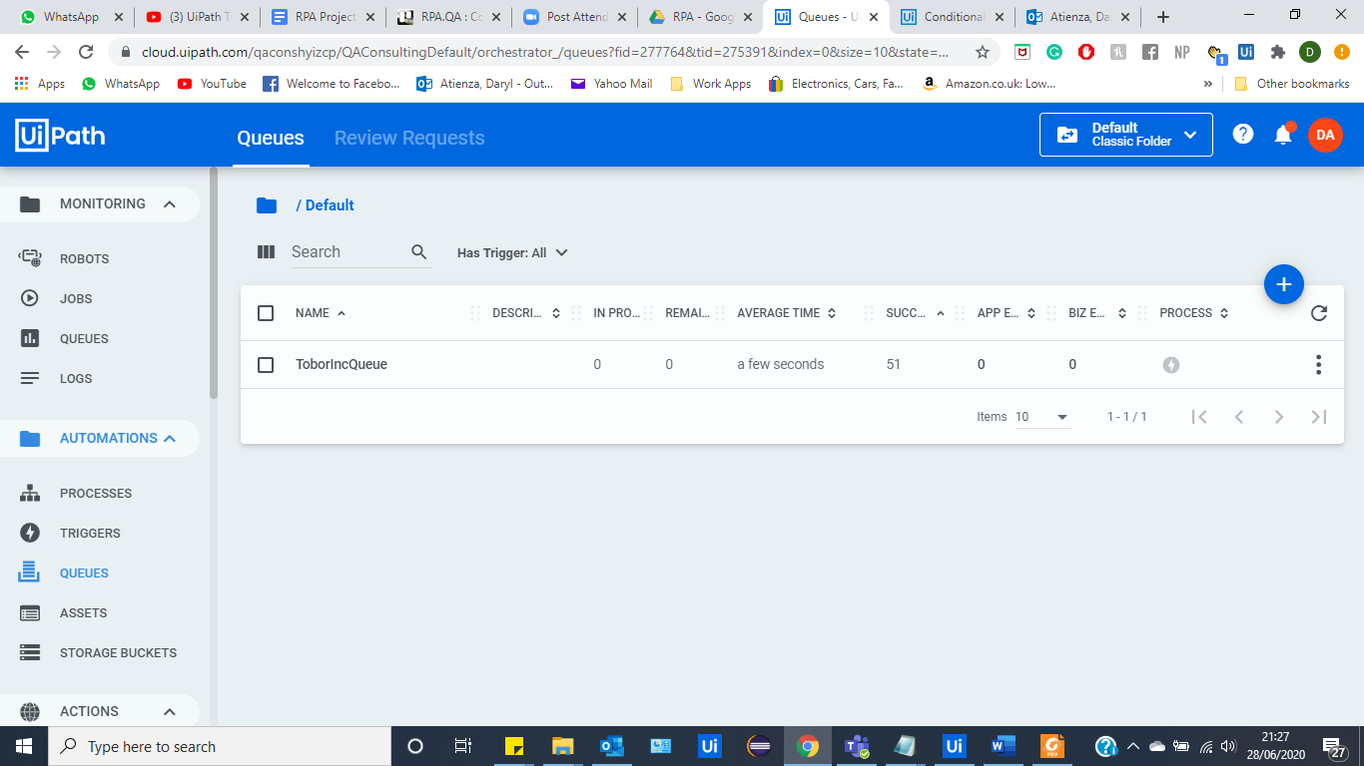
* This allows the robot to proceed to the next automation step, which is content aggregation, where it accesses the items within the queue (51) and uses the information from each item, to send the aggregated content, accordingly.

### 4.1.5 Content Aggregation:

* The robot will begin the automation by scraping information websites (specifically picked by the company). For this project a total of 9 unique websites were chosen, as there were 3 different content categories that user’s were able to choose from- these were; sports; gaming; dance.   
    
  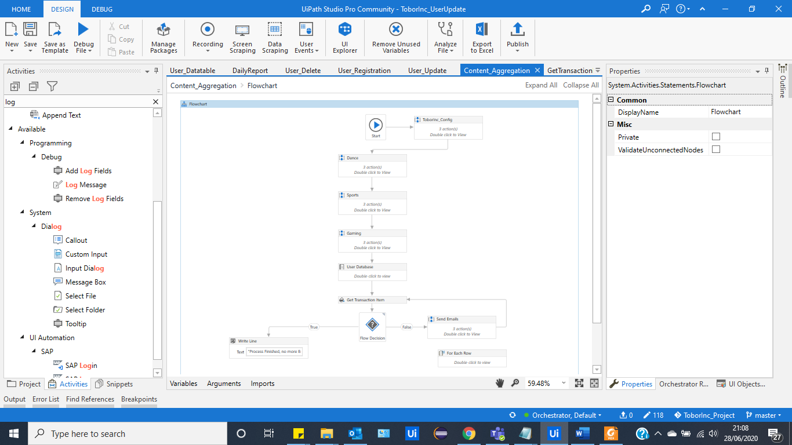  
  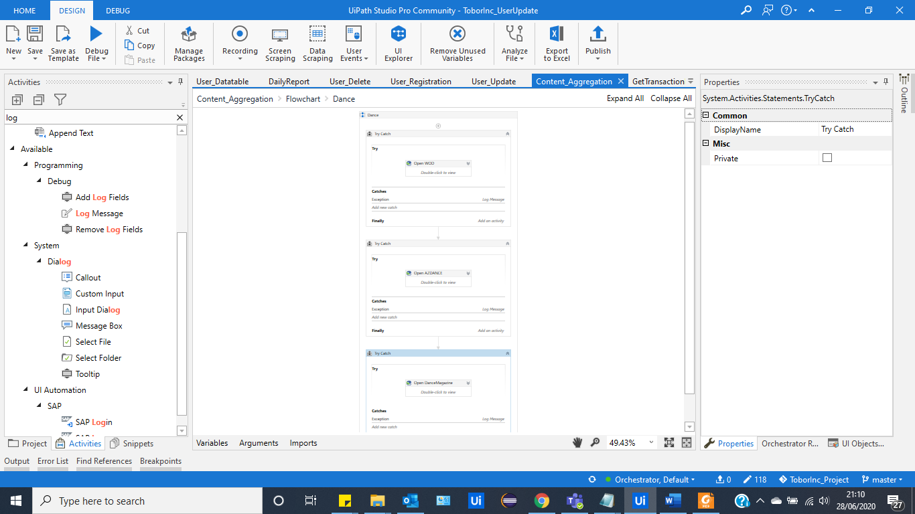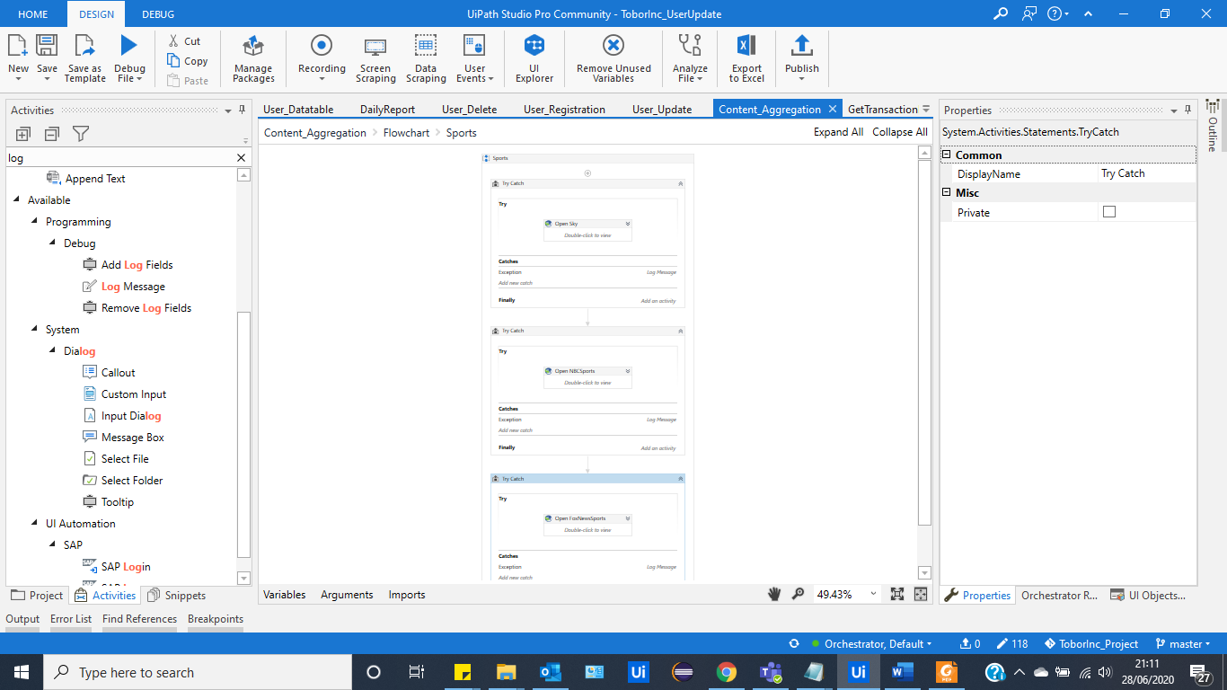 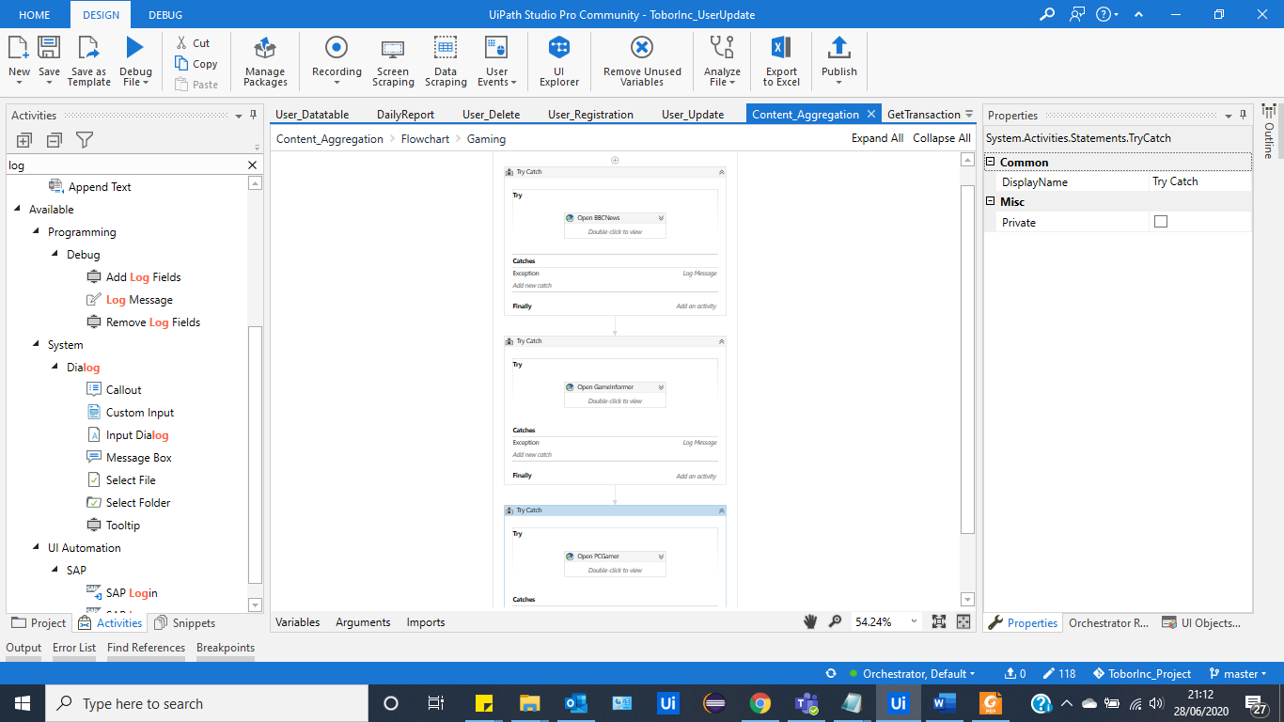
* Once Collected, the robot will then read through the user database.   
  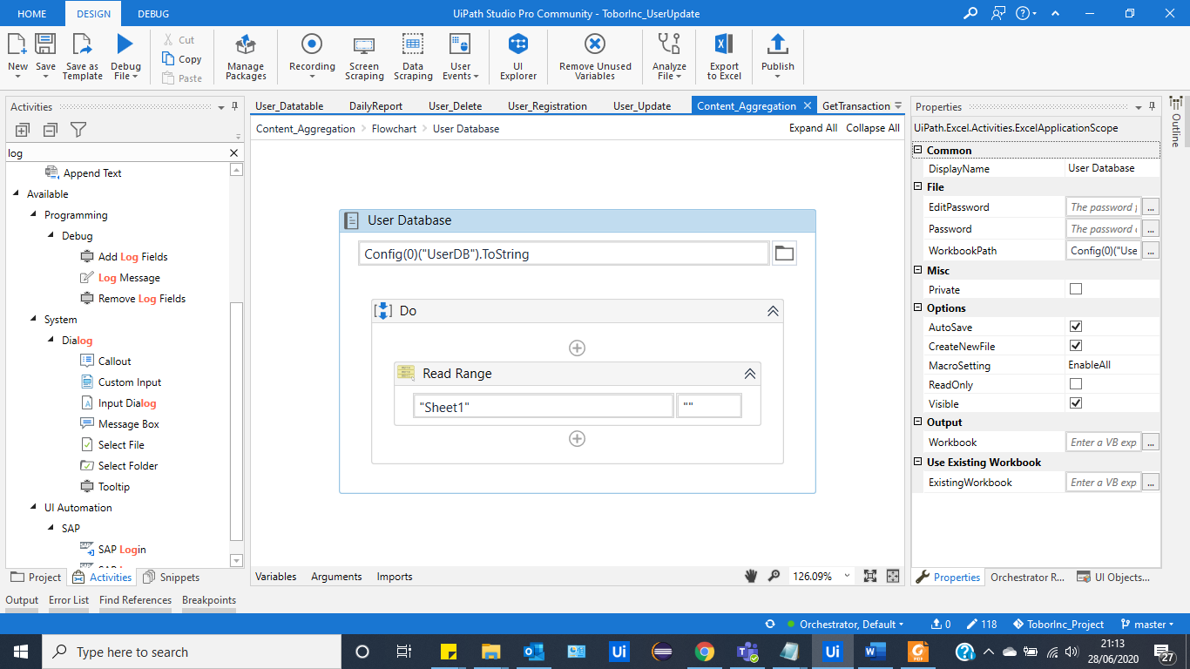
* From there, the robot will then access the orchestrator, which contains the database user information, and it will go into a “flow Decision”, which allows the iteration through the process of sending off an email, according to the specific content preference each user has opted for.   
  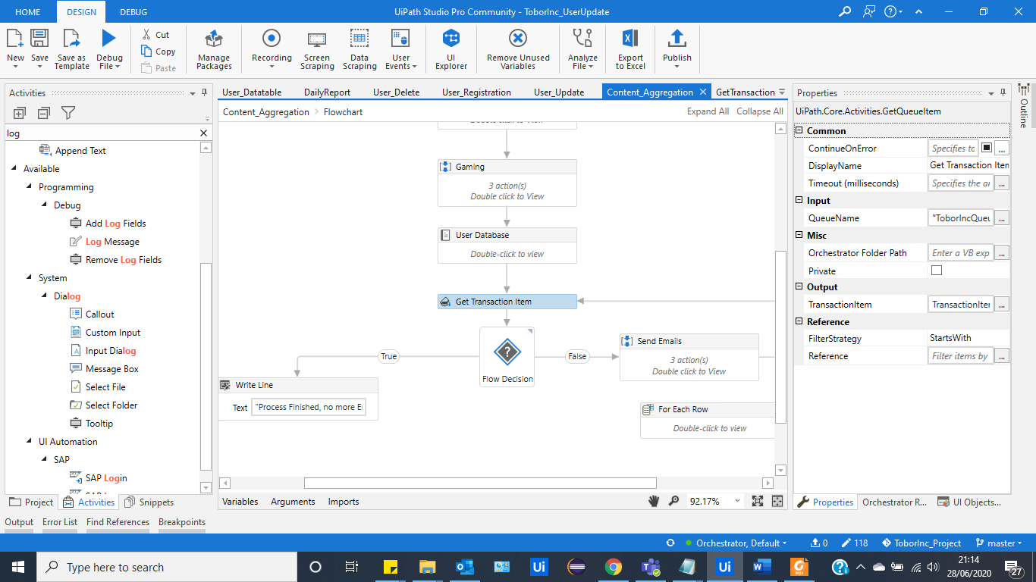
* The Robot reads the content preference, located in the transaction item information, and specifically chooses all users who have stated their content preference to be Gaming. Once found, the robot will send an email which contains the aggregated content of their choice.   
  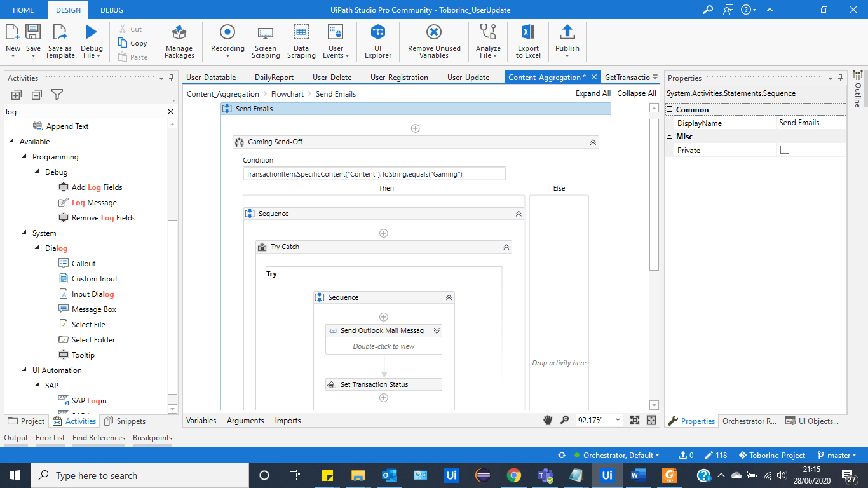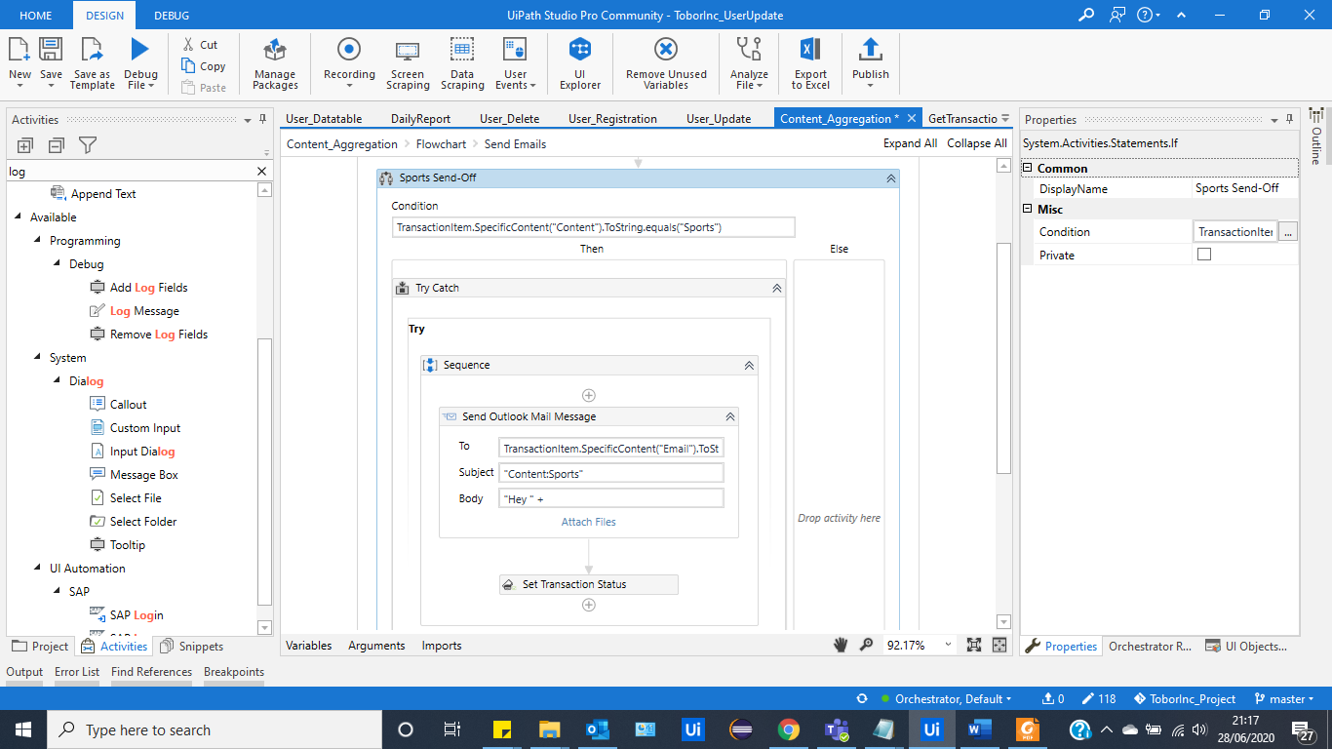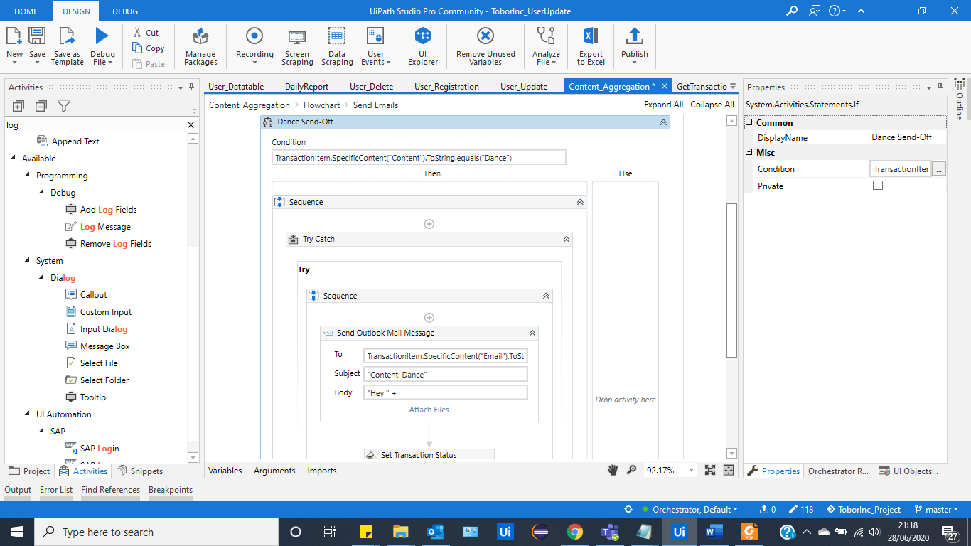
* The Flow Decision in the work-flow allows the robot to iterate through the transaction items, and send the emails accordingly, until there are no more users to be processed.   
  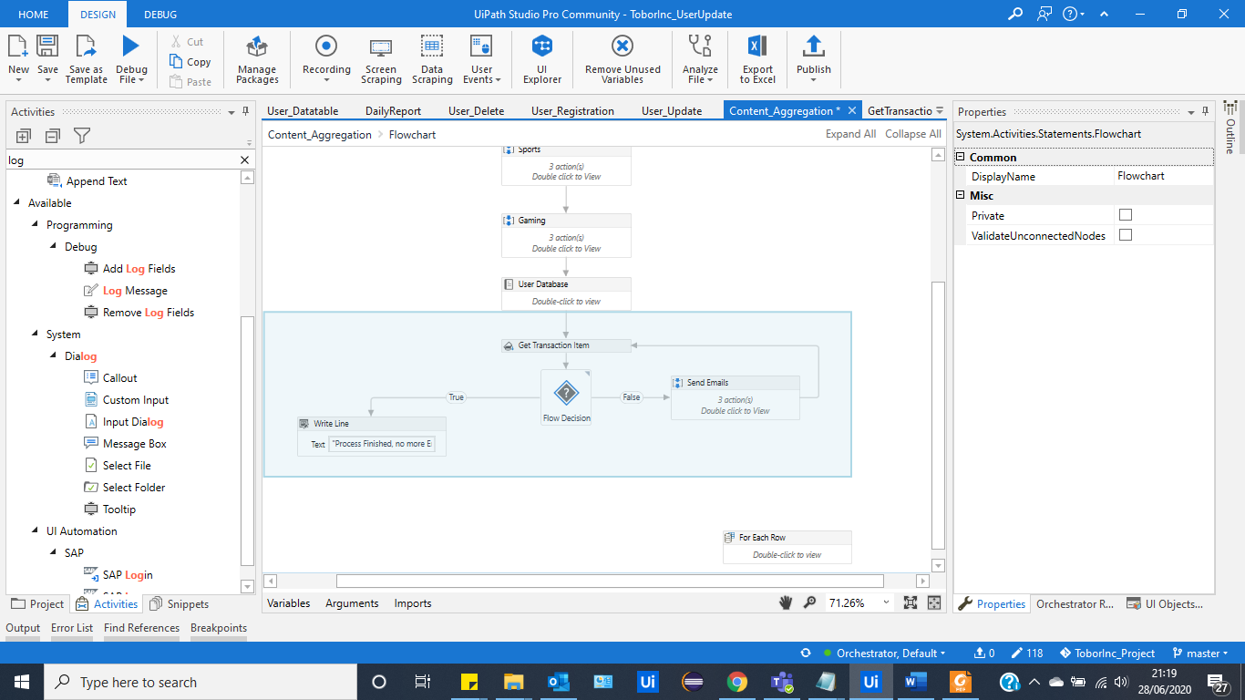

## 4.2 Reporting

### 4.2 Performance Reporting

Once the processes have successfully completed a report of the daily activities will be emailed to Tobor Inc., this is emailed on the daily.

* On the daily, the robot will automate a daily report send-off to Roberto. It will access the Tobor Inc inbox and send items, and will compile a document which contains the history of actions that were conducted during that day.   
  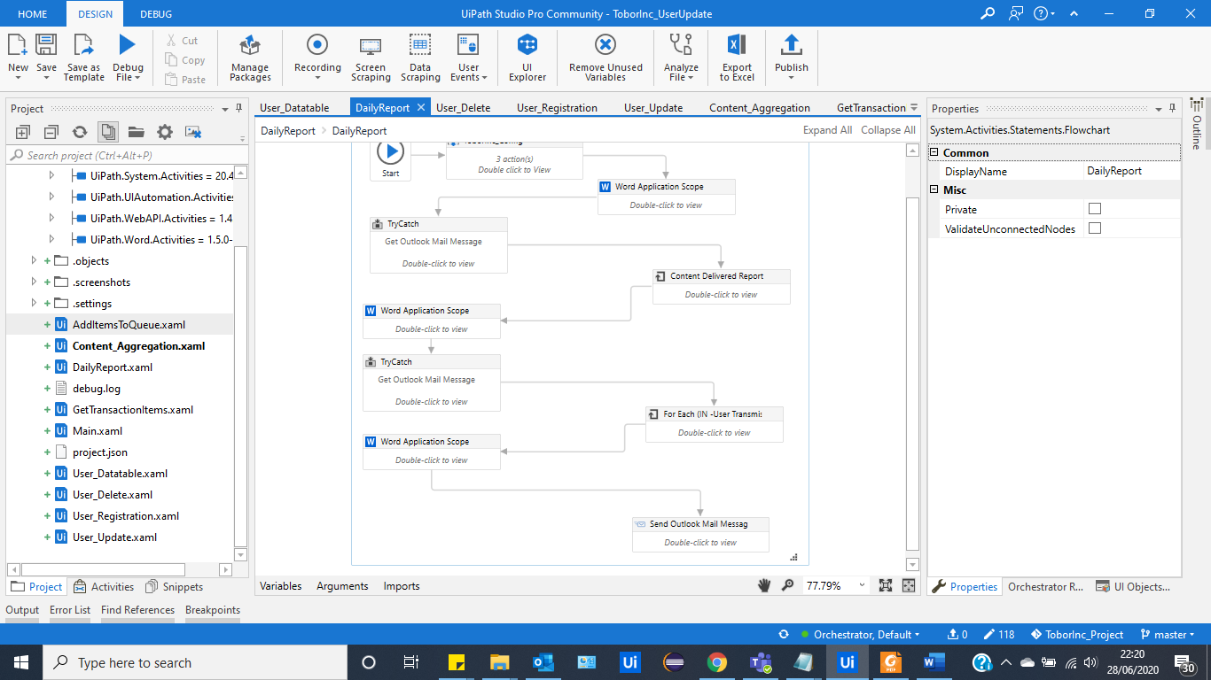
* The robot scrapes all the sent information, and compile the email information to readable sections that contain:  
  - Name of User that the email is sent to.  
  - Time and Date of action.   
  - Email Address of User.  
  - Content Preference.   
  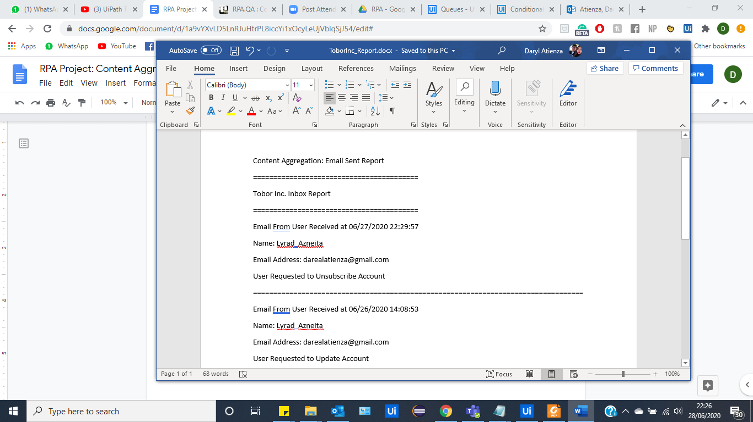
* The robot will also scrape the inbox of the company, and it will also take on all the information that the:  
  - Name of User that the email is sent to.  
  - Time and Date of action.   
  - Email Address of User.  
  - The Action that the email called for (Registration/Update/Unsubscribe).
* The final word document is then exported as a PDF, and sent to Roberto at the end of the day, for analysing.   
  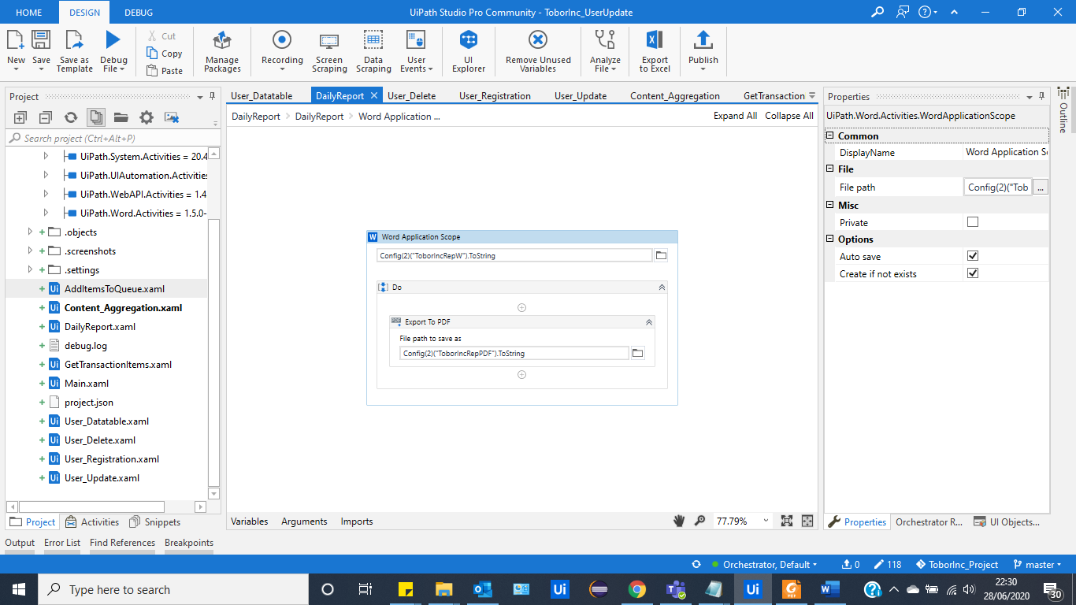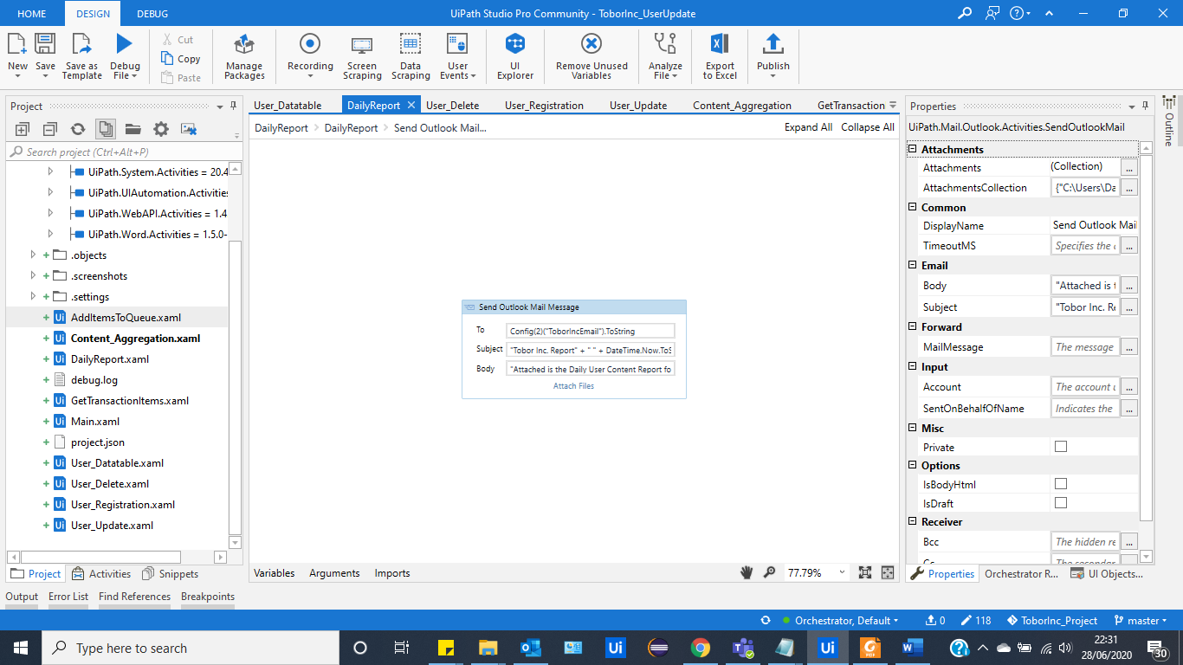  
  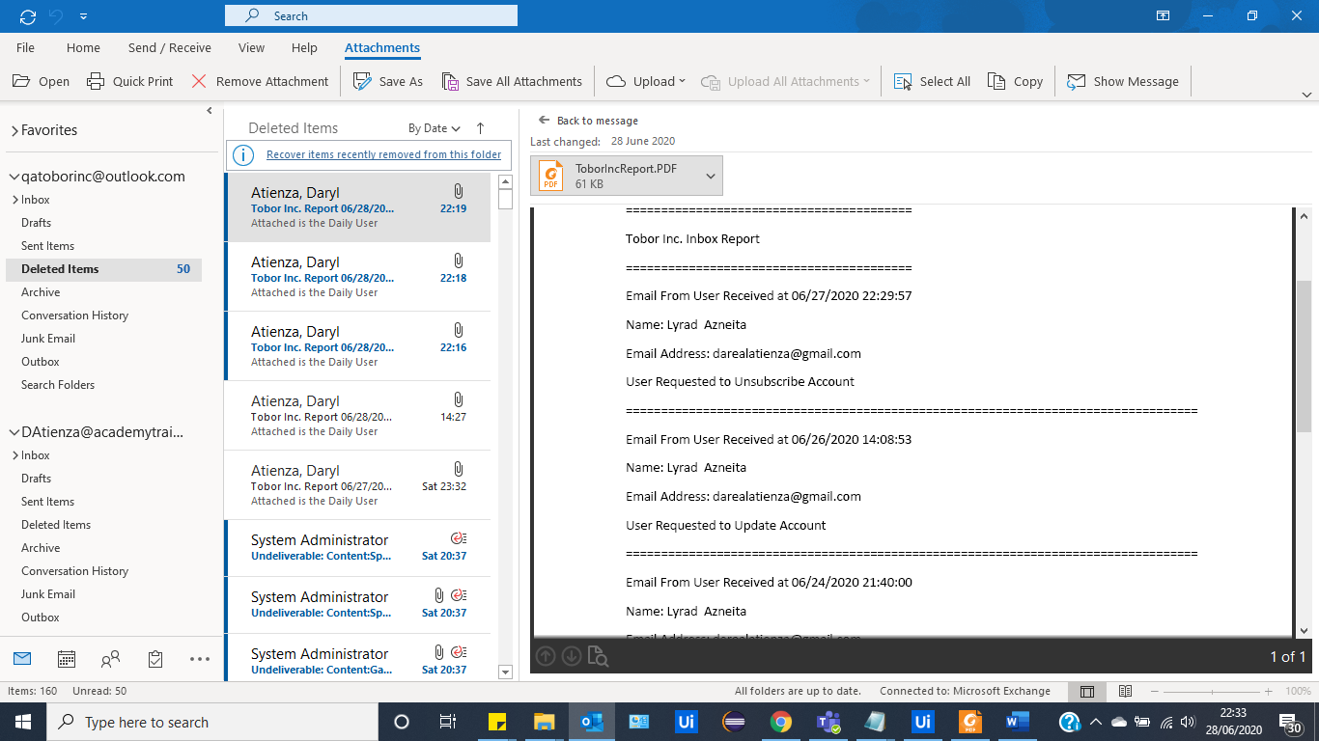

### 4.2.4 Triggers

* According to the requirements and information gathered, the initial automation begins when the company receives an email that fits one of the categories intended for either user registration/update/delete.
* Certain “triggers” such as daily and weekly sends off are decided by the user. Within the orchestrator, triggers can be used to decide which emails get sent off at which intended intervals.